**DUE DILIGENCE TO BE REPORT:**

**The below are the topics are for To be report**

How the process should be is what is mentioned in the report.

**Sheet 2:** Scope, approaches & deliverables

This is a standard slide (confirm this with Suhel)

**Sheet 3:** Process Understanding: is what we think the process is . Anything that stands out for example 1200 cases at a time in Process overview is mentioned explicitly.

Job description is something that we get from the client.

Complexity we have our own calculator where we calculate.

Process scope is what are the transactions that we are going to deal with 3

Out of scope is something that is out of scope

System availability: client gives the enough.

This same above process is followed for 4 processes.

**Sheet 7:** Executive Summary:

1. Scope & Deliver location:

It provides details about what this process is all about. At the time of transition Prudential would have told us the number of FTE to be transitioned. Those needs to be mentioned in Scope & delivery location.

In the document it is mentioned as 14 but now it is reduced to 10 FTE. A standard commentary like statutory …….

There is a standard line called as”No statutory, legal or licences………..”

There is also a standard line like No ongoing projects or planned change impacting the in-scope processes…… This is done to ensure that there is no transformation on going on the processes identified to be transitioned. As it becomes to transition the process for EXL.

People hiring:

Transition & Knowledge transfer: we will show the model we follow

How many times it takes post discussion with client?

1. Mention about external hiring

d)Transition & Knowledge transfer: We would already have discussions with client initially about the time it takes to transition the process. So, these will be mentioned here.

Operating window: is what we mention about the shift time.

**Sheet no 8: Executive summary:** This is a checklist that will be there (ask when this created)

**Sheet no 9: FTE estimation:**

We receive from the client. In this process the client had mentioned that we need to transition their QA those topic also needs to be mentioned here. Later these two FTE will be merged.

We will mention the risk that FTE calculation will be based on estimated effort requirements as shared by Prudential & then time & motion study will be conducted during ramp phase.

**Sheet 10**: KT model:

This is a standard slide used.

**Sheet11:** Proposed implementation plan:

Here we will mention the project plan.

Next, we mention the training timelines, in this report we have divided into two batches. The client did not agree to the option 1. The client also wanted the batch to be cross skilled which is done.

**Sheet 13: Training framework:**

Is a standard slide. This does not change but a few aspects will be added or deleted.

**Sheet 14: Performance metrics:**

The data mentioned here is what we got from client. Time services means by when the tasks should be completed.

**Sheet 15: Proposed Ramp targets:**

This is something that we create and we propose it to client(how do crate the proposal of ramp plan , do u straight away create it or do you check with Jagan)

**Sheet 16: Parallel run:** Check with Suhel what is this

**Sheet 18:**

Quality analysis certification plan:

This slide we get from quality certification team.

**Sheet 19:** Governance model:

This is our slide. We created this.

**Sheet 20:** Governance during training & Parallel run:

This is a standard slide.

**Sheet 21** Support required from Prudential

This is also a standard slide. The details about this slide is that what we are going to do & what support we need from Prudential.

**Sheet 22**: Proposed EXL Operating structure

This slide is worked on when creating a particular checklist(Check with Suhel which Checklist it is).

The details of this slide is that how will the team structure look like when the team moves to EXL.

**Sheet 23:** Next steps:

Here in this slide it will mention about the next steps.

**Sheet 26: Production work flow:**

Here the process map will be the same but minor changes will be there.

**Sheet 31: Work allocation**:

This is also more of a standard slide.

**Sheet 32**: **Process documentation:**

This slide is about what we check.

**Sheet 33: Skill set requirement:**

This slide was provided by the client prudential

**Sheet 34-37: Migration readiness assessment:** We have a calculator for this based on which the calculations are done. Refer the tracker by the name MRA assessment shared by Suhel.

**3rd August:**

**For your information: Clarifications of To be report**

**Due Diligence: To be report out:**

Sheet 8: Executive summary:

* What does Work in progress mean on segregation of activities for in scope processes?

We have these four processes in Prudential & it will not remain the same as it comes to EXL. The transition is only for back-office work of four processes. There will be front office work & that needs to be segregated.

In Technology connectivity, Existing MPLS connection to be leveraged. List of applications & access process define” what does this mean ?

Other MPLS there is another connection which is mentioned in induction courses. There is one that is cheap & the other one that is expensive (refer conduction course) here Prudential being an existing client we can always use the same LAN for connectivity. List of application & accesses are those that the team in Prudential is going to use.

Sheet 10: Daily & weekly meetings between Prudential & EXL stakeholders to discuss the progress & report any anomaly”. How do you come to decide that these are the frequency, does the client suggest or does transition manager suggest?

This is standard practice that we follow , we conduct daily meetings & one weekly meeting. We start with this suggestion & then we leave it to the client if they want meeting at lesser frequency.

Details about ABS Process: Initially the process had 14 FTE then the client informed that 2 FTE work will be done by their Bots. Later it was reduced to 2 more.

**Sheet 11: What is Nesting phase?**

Nesting phase is nothing but hands on practice. It is that phase where you, will start processing the traction but you will not be responsible for that phase. So the associates will be processing the transactions & will be reviewed by the client. In Nesting phase there will not be any target but in ramp phase there will be a target.

Here whatever is mentioned is open for discuss ion with the client as it is just a proposal from our end.It is not that we are putting this proposal for the first time already there would have been discussions with client.

**How does a Transition manager go ahead with Ramp process,**

Ramp is the time where the operations team process. There will be targets as well . It could be possible that for 1st week I will process 20% of transactions, now we check with the client to know how long it takes to come up the learning curve to perform at their full potential.

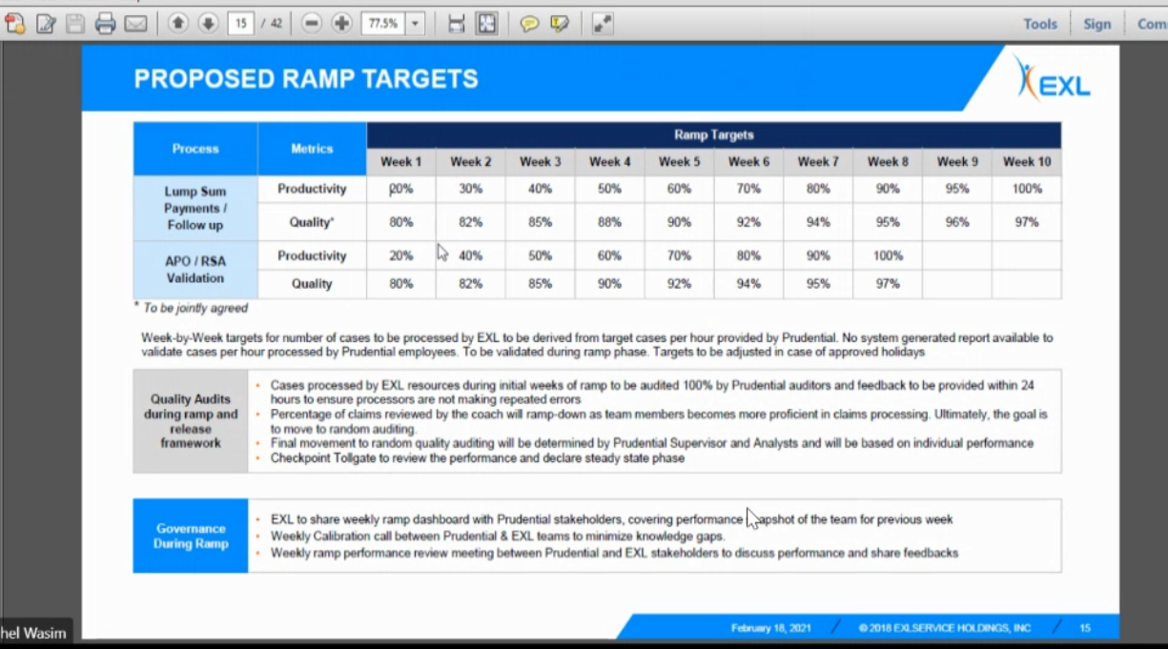

If you notice in the above screen shot Ramp target for 1st week was 20% but later in every week the target kept on increasing. In week 10 the productivity is 100%.

Ramp targets usually are given by EXL. The clients just agree to it. The quality & other aspects sometimes client might increase the percentage or lessen it . Hence it is important to have a discussion.

**Sheet18: Quality analysts certification plan**: Is the content used is standard wording?

This slide the quality team has created. It is a standard slide that will come from the quality team. Here the process is that Prudential is an existing client but if it is a totally new client then we need to get in to a call to have discussion about quality perspective if the client has a different view.

**Sheet 21: Support required from Prudential:**

This is a standard slide used. Here in this slide we have given them two scenarios which is steady state or BAU & Migration phase.

Sheet 25: Excel Scope : This slide we have created on the basis of discussions that we had with this client. The client did a process demo & where they explained for each process say Follow up letters what is applicable for us. For lump sum payment the client gave a exhaustive details.

Sheet 34: Migration readiness assessment: With whom did you prepare this slide with:

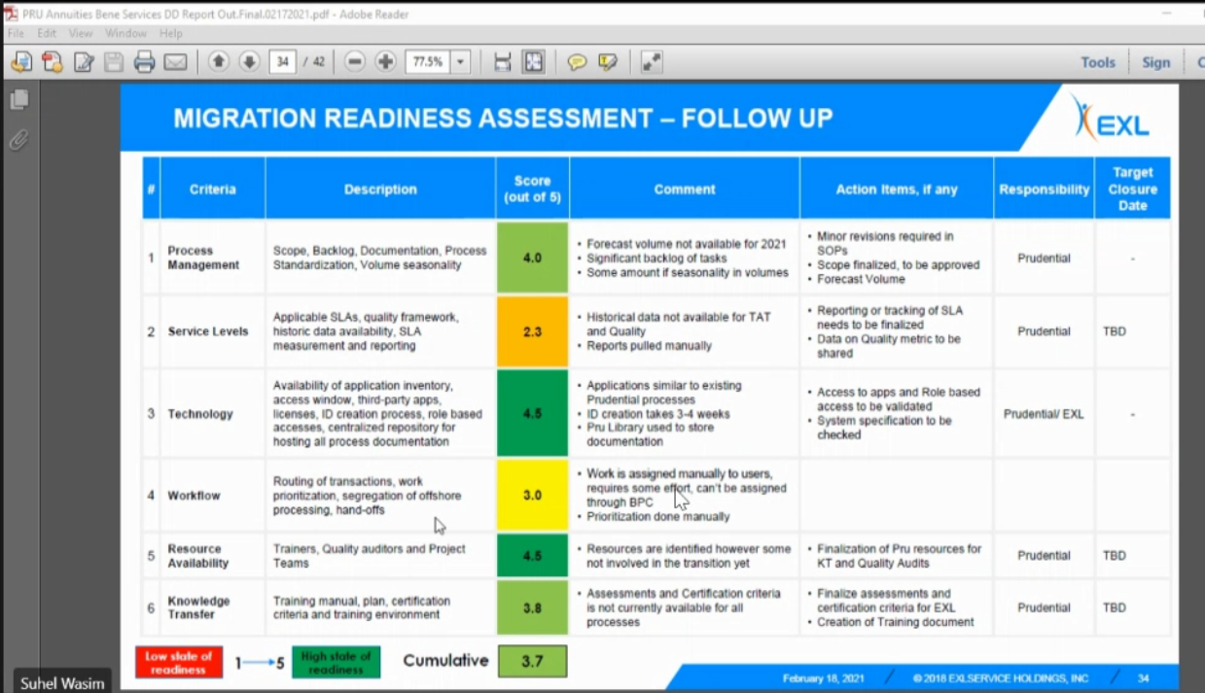

The following is the file used to arrive at the above Migration readiness assessment file.

The below file / template should be used for each process, here in this case there are four processes so four time this file has been used. The ratings can be choosen from 1 to 5 & those details are mentioned in the column B which is Readiness scoring guideline. The rating was given by Transition manager after discussing with client.We share it with client & explain them this is how we share the readiness, we check if you are fine with this.

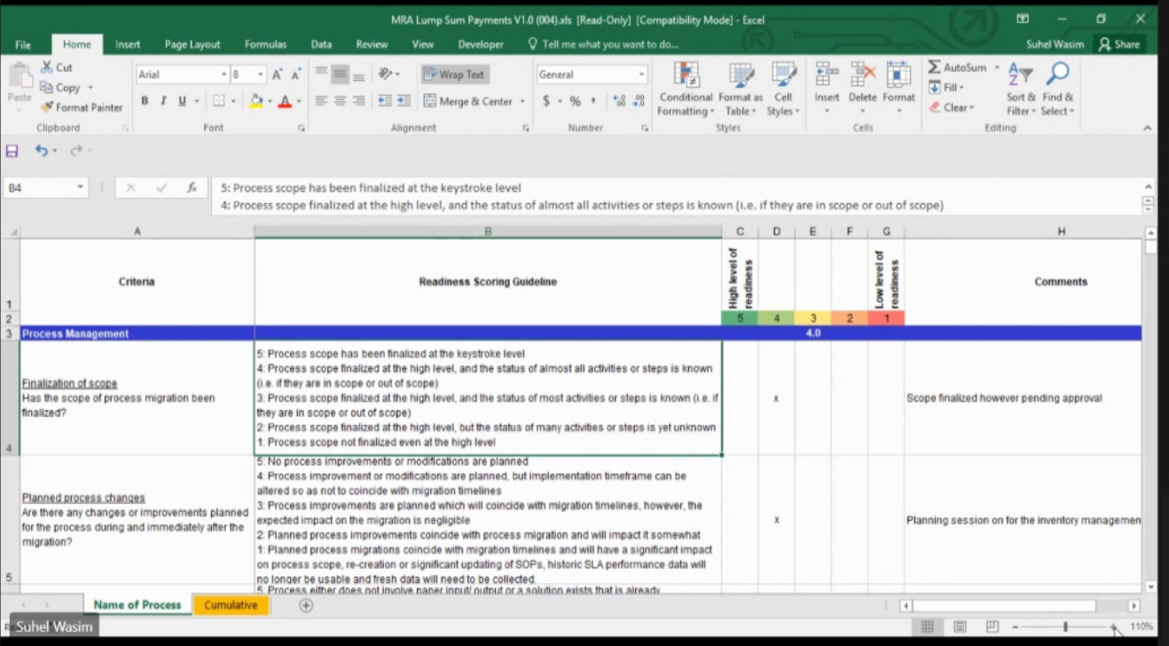

Comments in the slide is given to justify the rating.

**Sheet 38: Key risks & associated mitigation plan:** This has been prepared by Suhel based on what he thinks about the process.

**New topic: Complexity calculator:** There is a template used to check the complexity of the process, that is known as complexity calculator

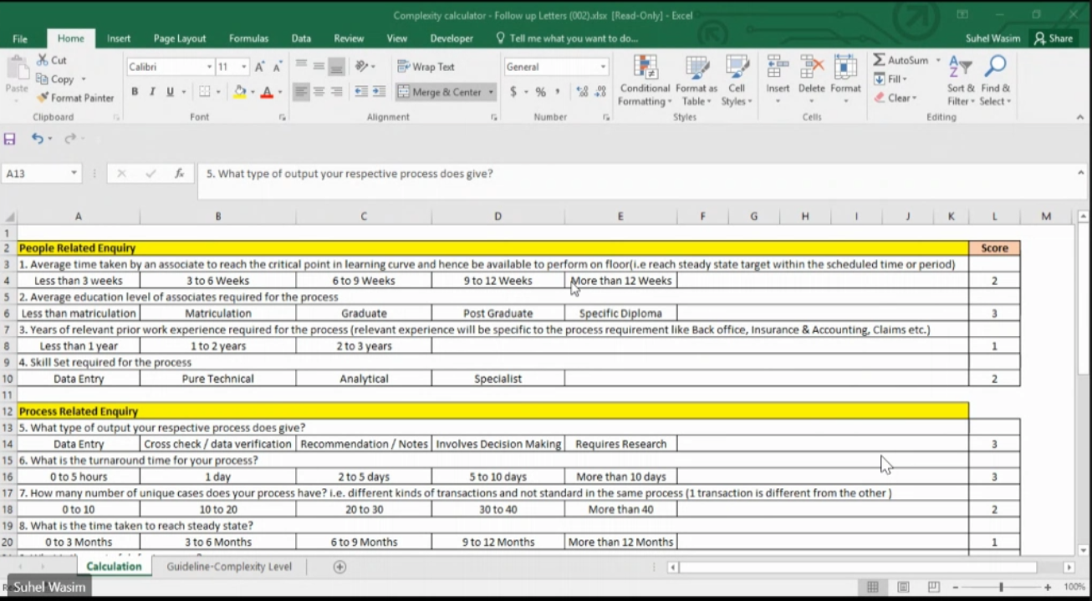

When is this complexity calculator used

Update the questionnaire by verifying the timelines.